**32. Design TM using simulator to perform string comparison where w={aba aba}**

**AIM:** To design TM using simulator to perform string comparison where w={aba aba} **TRANSITION DIAGRAM:**

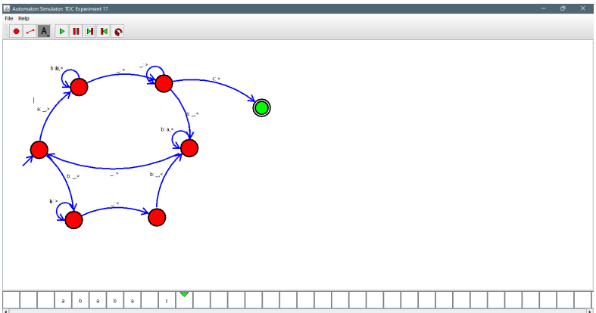

**RESULT:** Hence designing TM using a simulator to perform string comparison